USA Flights Data Analysis Report

INTRODUCTION 1
DATA 2
Airlines Sample Data 2
Airports Sample Data 2
Flights DataSet is composed of following variable 2
Cleaning Data 4
Feature Selection 7
Using Random Forest 7
Using Principal Component Analysis(PCA) 7
Correspondence between features and Classes 8
Classifiers 9
Random Forest Classifier 9
Logistic Regression Classifier 10
Decision Tree Classifier 11
Cross-Validating the Classifier 12
OUTPUT 12
BEST PARAMS 13
Confusion Matrix and Classification Report for Training Data 13
Confusion Matrix and Classification Report for Test Data 14
Clustering 16
K-Means Clustering 16
Hierarchical Clustering 16
Patterns In Dataset 17
CLASS TRENDS 17
Arrival & Departure Stats 18
AVERAGE DELAY OF AIRLINES 18
Cancelled Flights by Reason 19
RESULTS 20

INTRODUCTION
Given dataset contains data of 1048575 distinct flights during the year 2015. Data contains information about delayed, diverted, cancelled and on time flights. Almost 38% percent of the flights were delayed by some amount of time either due to weather, security or airline issues. These delayed flights end up costing customers as well as the Federal Aviation Administration. Main goal of this project report is to summarize any or all causes of delayed, diverted or cancelled flights.
This report summarizes the findings of our assessments using the data mining concepts. Firstly, we cleaned the data in order to apply the algorithms efficiently. Then, we applied algorithms like Random Forest, Logistic Regression and Decision Tree Classifiers. We analyzed the speed and results of the algorithms. Further we moved towards dimensionality reduction to reduce our computing cost. Previous algorithms were again applied and analyzed. Lastly, we found patterns of classes depending upon single or multiple features.

DATA

Airlines Sample Data
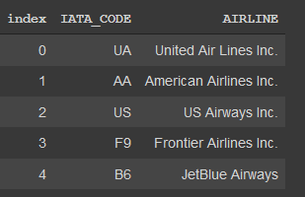

Airports Sample Data
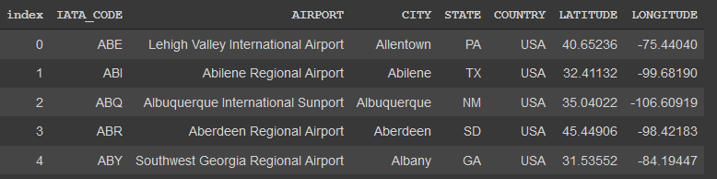

Flights Dataset is composed of following variable
YEAR | 2015
MONTH | 1-3
DAY | 1-31
DAY_OF_WEEK | 1(Monday) - 7(Sunday)
AIRLINE | Airline Identifier
FLIGHT_NUMBER | Flight Identifier
TAIL_NUMBER | Aircraft Identifier
ORIGIN_AIRPORT | Starting Airport
DESTINATION_AIRPORT | Destination Airport
SCHEDULED_DEPARTURE | Planned Departure Time(hhmm)
DEPARTURE_TIME | WHEEL_OFF - TAXI_OUT (hhmm)
DEPARTURE_DELAY | Total Delay on Departure(minutes)
SCHEDULED_TIME | Planned time amount needed for the flight trip  (minutes)
AIR_TIME | The time duration between wheels_off and wheels_on time(minutes)
DISTANCE | Distance between two airports(miles)
SCHEDULED_ARRIVAL | Planned arrival time
ARRIVAL_DELAY | ARRIVAL_TIME-SCHEDULED_ARRIVAL
DIVERTED | Aircraft landed on airport out of schedule 0/1
CANCELLED | Flight Cancelled 0/1
CANCELLATION_REASON | Reason for Cancellation of flight: A - Airline/Carrier; B - Weather; C - National Air System; D - Security
AIR_SYSTEM_DELAY | Delay caused by air system (minutes)
SECURITY_DELAY | Delay caused by security (minutes)
AIRLINE_DELAY | Delay caused by the airline (minutes)
LATE_AIRCRAFT_DELAY | Delay caused by aircraft (minutes)
WEATHER_DELAY | Delay caused by weather (minutes)
TAXI_OUT | The time duration elapsed between departure from the origin airport gate and wheels off
WHEELS_OFF | The time point that the aircraft's wheels leave the ground
TAXI_IN | The time duration elapsed between wheels-on and gate arrival at the destination airport
WHEELS_ON | The time point that the aircraft's wheels touch on the ground
ELAPSED_TIME | Time elapsed

Cleaning Data
Data after removing unnecessary columns or combining two or more columns is given below. Dimensionality, after cleaning the data, was reduced from 17 to 32.

DATE | YEAR MONTH DAY
DAY_OF_WEEK | 1(Monday) - 7(Sunday)
AIRLINE | Airline Identifier
ORIGIN_AIRPORT | Starting Airport
DESTINATION_AIRPORT | Destination Airport
DEPARTURE_DELAY | Total Delay on Departure(minutes)
SCHEDULED_TIME | Planned time amount needed for the flight trip (minutes)
AIR_TIME | The time duration between wheels_off and wheels_on time(minutes)
DISTANCE | Distance between two airports(miles)
ARRIVAL_DELAY | ARRIVAL_TIME-SCHEDULED_ARRIVAL
CANCELLED | Flight Cancelled 0/1
CANCELLATION_REASON | Reason for Cancellation of flight: A - Airline/Carrier; B - Weather; C - National Air System; D - Security
TOTAL_DELAY | SUM OF AIR_SYSTEM_DELAY, SECURITY_DELAY, AIRLINE_DELAY, AIRLINE_DELAY, LATE_AIRCRAFT_DELAY, WEATHER_DELAY
TAXI_OUT | The time duration elapsed between departure from the origin airport gate and wheels off
WHEELS_OFF | The time point that the aircraft's wheels leave the ground
TAXI_IN | The time duration elapsed between wheels-on and gate arrival at the destination airport
WHEELS_ON | The time point that the aircraft's wheels touch on the ground
ELAPSED_TIME | Time elapsed

Feature Selection

Using Random Forest
We used trained random forest classifiers to extract the features used to decide the class of a training example which reduced the dimensionality of data as well as the cost of training and testing. Following Features were mostly used in deciding the class of a training example.
- DEPARTURE_DELAY
- ARRIVAL_DELAY
- ARRIVAL_DELAY_STATUS
- ON_TIME
- CANCELLED

Using Principal Component Analysis (PCA)
Principal component analysis (PCA) is a technique used to emphasize variation and bring out strong patterns in a dataset. It's often used to make data easy to explore and visualize. The main idea of principal component analysis (PCA) is to reduce the dimensionality of a data set consisting of many variables correlated with each other, either heavily or lightly, while retaining the variation present in the dataset, up to the maximum extent.
Using PCA we further reduced the dimensions of our data from 17 to 7 while retaining 90 percent of the variance in the data.

Correspondence between features and Classes
Correspondence is calculated through correlation. Correlation varies from negative 1 to positive 1. Negative correlation means variables behave opposite to each other. Positive correlation means variables move together. Zero correlation is equivalent to no relation between variables.
Correspondence of features before selecting best features.
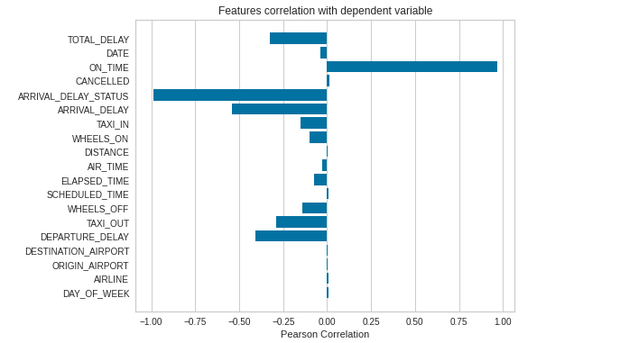
It's evident from the graph that out of all features ON_TIME, ARRIVAL_DELAY_STATUS, ARRIVAL_DELAY and DEPARTURE_DELAY heavily relates with Y which is representative of our classes. Correspondence of features after selection of important features.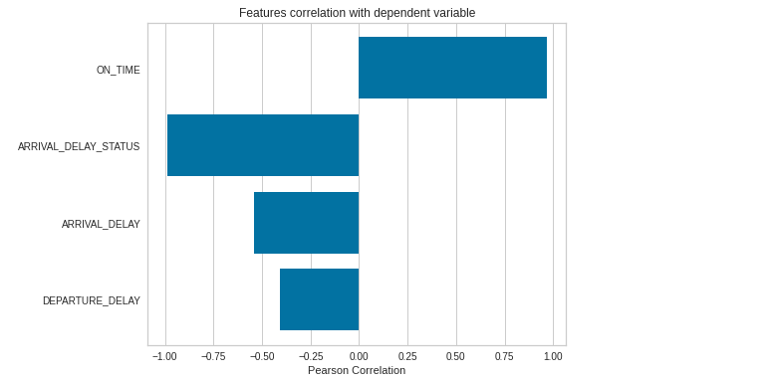

This graph shows that all the features are important as they relate with Y.

Classifiers

Random Forest Classifier
We applied a random forest classifier with 100 trees and it classified our data with f1-score of 1 across the classes. The problem with it was that most of the features were not used to make decisions which in result affected the speed of the classifier.
Solution:
We then applied feature selection. Features were selected on the basis of importance in decision making. Feature selection algorithm was also based on random forest. Following 3-5 features were mostly being used for classifying the examples
- DEPARTURE_DELAY
- ARRIVAL_DELAY
- ARRIVAL_DELAY_STATUS
- ON_TIME
- CANCELLED
With the decrease in features, label 1 and 2 are confused with each other.
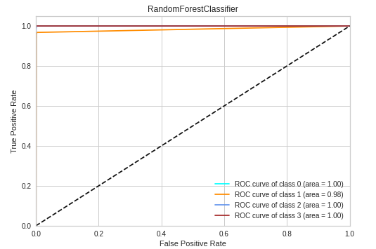

Logistic Regression Classifier
All variations of logistic regression failed to converge for this data.
Solution:
In order to converge the logistic regression, we scaled our data. Scaling helped in convergence. Out of all the logistic regression algorithms only Stochastic Average Gradient gave maximum results in reasonable time. All other algorithms took too long to give results. Despite its SAG’s convergence, its speed is a major issue.
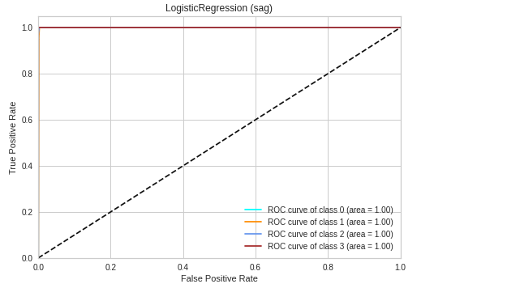

Decision Tree Classifier
Decision Tree worked fine for the dataset. It classified our data with f1-score of 1 across all classes. The problem comes when we apply it on scaled data. It confuses 1 with other labels. Another issue with this classifier was speed.

Solution:
Solution was to use it on unscaled data. This solution comes with the drawback of speed.
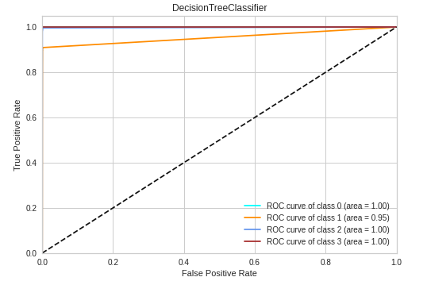

Cross-Validating the Classifier
Random Forest Classifier Param Grid
{
'max_depth': [10, 20, 30, 40, 50, 60, None],
'min_samples_leaf': [1, 2, 4],
'min_samples_split': [2, 5, 10],
'n_estimators': [100, 200, 300, 400, 500, 600, 700, 800, 900, 1000]
}

OUTPUT
Fitting 3 folds for each of 100 candidates, totalling 300 fits
[Parallel(n_jobs=-1)]: Using backend LokyBackend with 4 concurrent workers.
[Parallel(n_jobs=-1)]: Done 33 tasks | elapsed: 10.9min
[Parallel(n_jobs=-1)]: Done 154 tasks | elapsed: 51.0min
[Parallel(n_jobs=-1)]: Done 300 out of 300 | elapsed: 90.6min finished

BEST PARAMS
{
'max_depth': 60,
'min_samples_leaf': 2,
'min_samples_split': 5,
'n_estimators': 800
}

Confusion Matrix and Classification Report for Training Data

 | precision | recall | f1-score | support
0 | 1.00 | 1.00 | 1.00 | 277640
1 | 1.00 | 1.00 | 1.00 | 1590
2 | 1.00 | 1.00 | 1.00 | 25539
3 | 1.00 | 1.00 | 1.00 | 429233
accuracy |  |  | 1.00 | 734002
macro avg | 1.00 | 1.00 | 1.00 | 734002
weighted avg | 1.00 | 1.00 | 1.00 | 734002

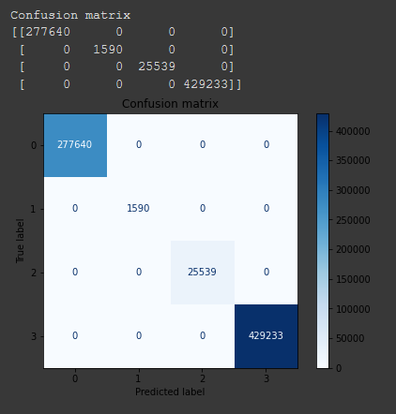

Confusion Matrix and Classification Report for Test Data

 | precision | recall | f1-score | support
0 | 1.00 | 1.00 | 1.00 | 118989
1 | 1.00 | 1.00 | 1.00 | 682
2 | 1.00 | 1.00 | 1.00 | 10945
3 | 1.00 | 1.00 | 1.00 | 183957
accuracy |  |  | 1.00 | 314573
macro avg | 1.00 | 1.00 | 1.00 | 314573
weighted avg | 1.00 | 1.00 | 1.00 | 314573

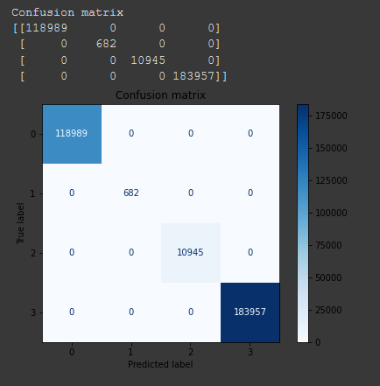

Clustering

K-Means Clustering
We used K-means clustering with k = 4 to see if the clustering algorithms made the same clusters as class labels but accuracy was very low (about 10 percent).

Hierarchical Clustering
We tried to use sklearn for hierarchical clustering to reveal any interesting cluster patterns but we ran out of memory(25GB) on COLAB due to the large size of the dataset.
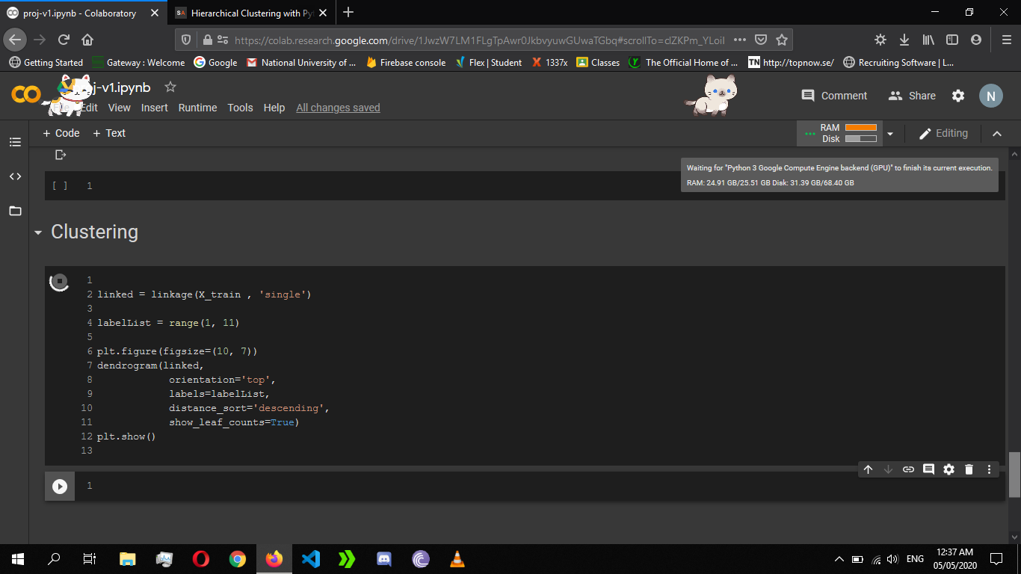

Patterns in Dataset

CLASS TRENDS
Firstly, we tried to find class trends with respect to airlines. Results were shown with the help of pie charts. Following is one example.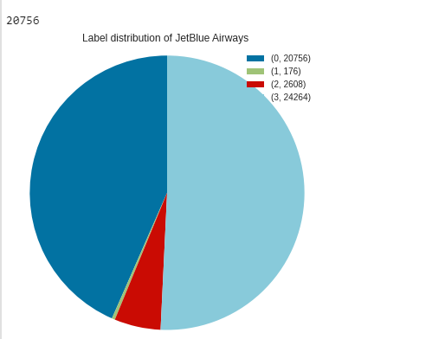

Secondly, we found class trends with respect to departing airports. Below is the example.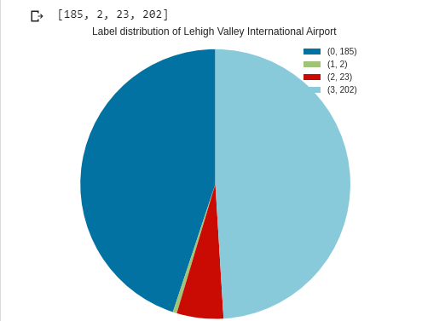
Lastly, class trends with respect to destination airports are calculated. Figure shows results for Arcata airport.
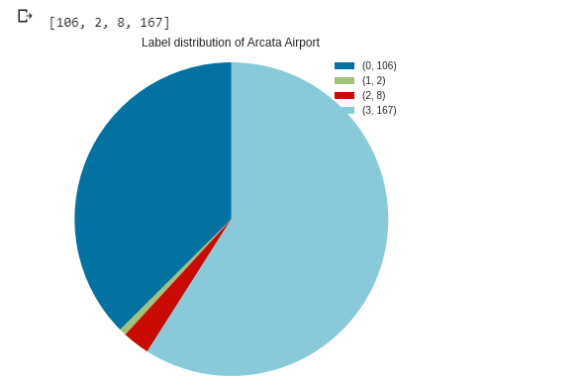

Arrival & Departure Stats

Arrival | Departure | Count | Class Dist.
on time | on time | 507623 | [1, 2, 3] => [ 88, 1711, 505824]
on time | late | 107803 | [1, 2, 3] => [ 63, 374, 107366]
late | on time | 113300 | [ 0 ] => [113300]
late | late | 283329 | [ 0 ] => [ 283329 ]

0. Delayed, 1. Diverted, 2. Cancelled, 3. On Time

AVERAGE DELAY OF AIRLINES
Average delay of delayed flights is 57.6. Furthermore, we calculated average
delay of every airline which is illustrated by figure.
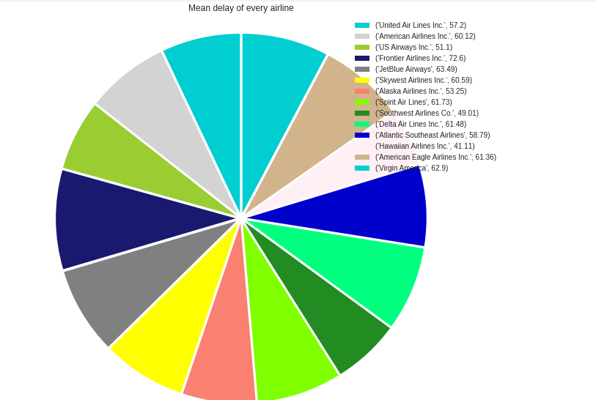

Cancelled Flights by Reason
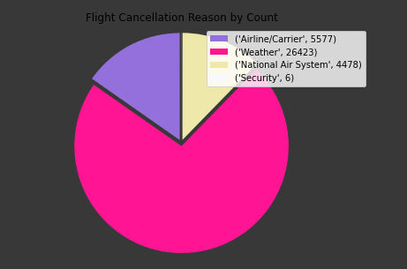

RESULTS
Over the course of this project we have examined the issue of how features affect the classes from a variety of different perspectives. Unnecessary data was removed which reduced our data size by 40%. We also used PCA and RF feature selection to reduce data size. We examined and analyzed the results of different classifiers and their speed with and without the reduction of the dataset. Random forest was the one with best results as well as speed.

